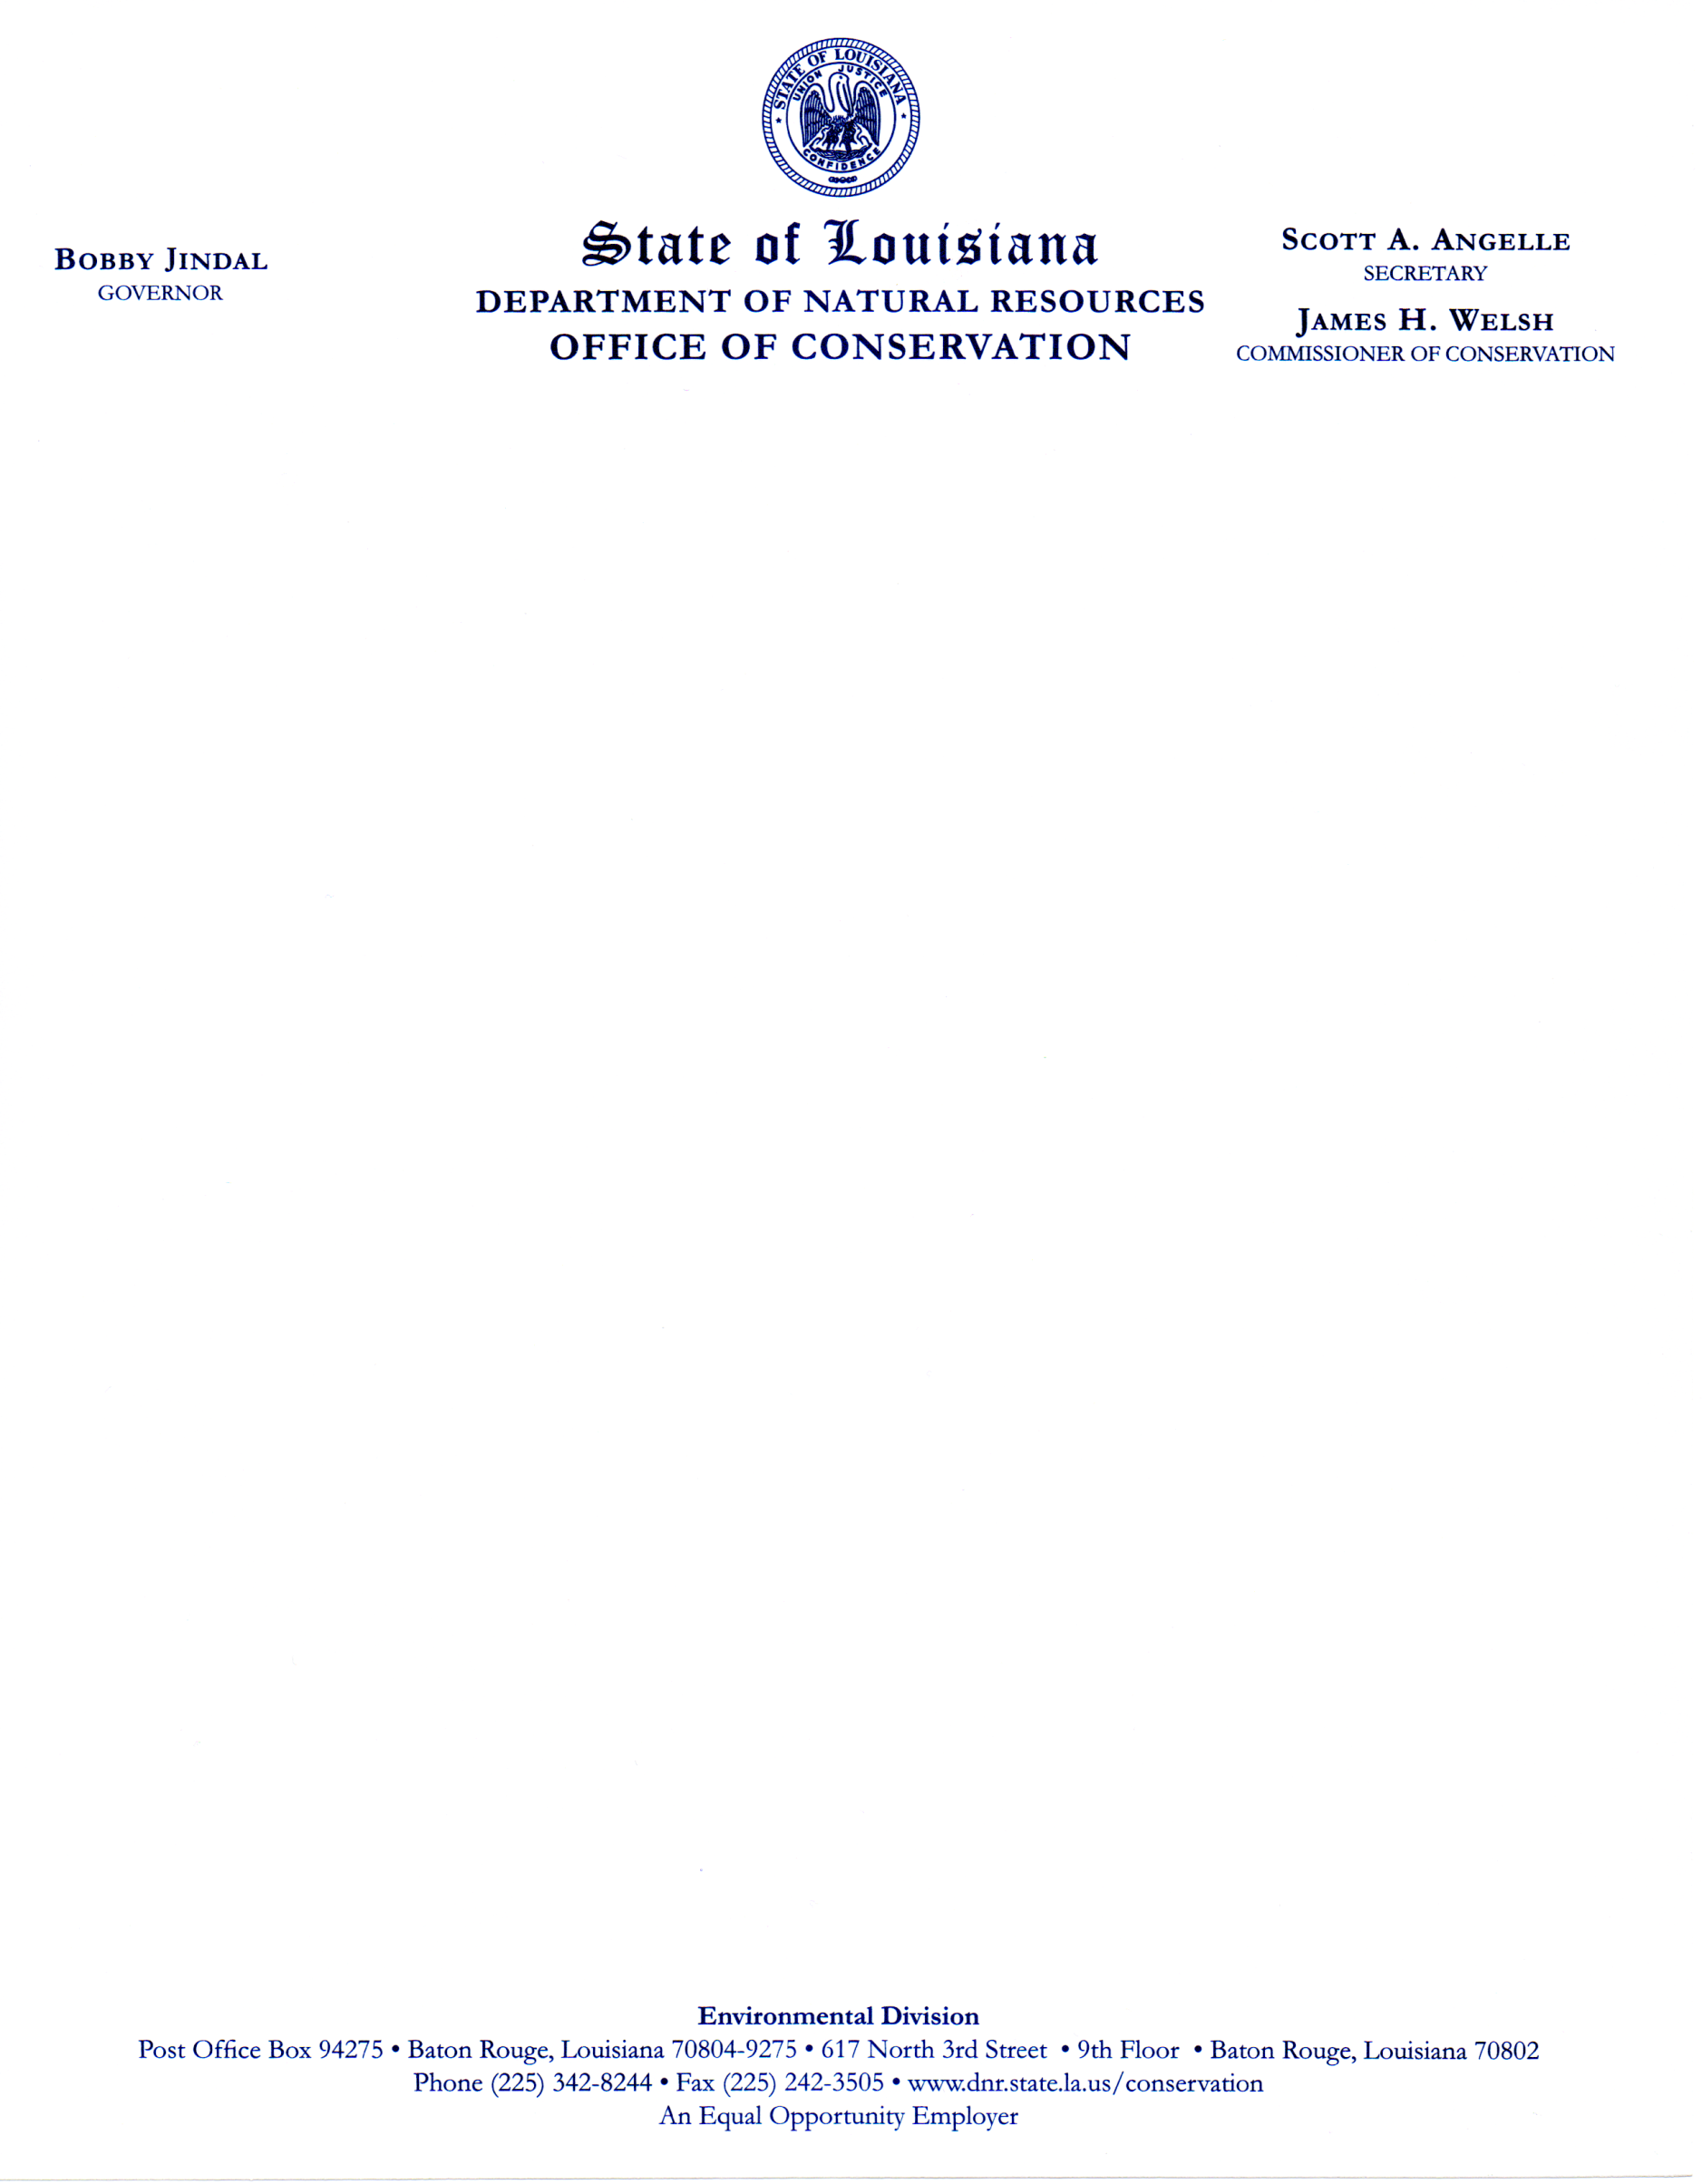

**Meeting Notice**

**The ADVISORY COMMITTEE FOR THE REGULATION AND CONTROL OF**

**WATER WELL CONTRACTORS (DRILLERS) IN LOUISIANA will meet on**

**Wednesday, May 11, 2011**

**12:00 P.M.**

**Griffon Room**

**LaSalle Building – 1st Floor**

**617 North 3rd Street**

**Baton Rouge, LA 70804**